Chapter 10 The nature of waves

Chapter test answers Total marks 53

Section A

Question 1

B. f = number of events per second =  = 2.70 Hz (1 mark)

Question 2

C. Superposition occurs. The waves add vectorially. Two crests will add their displacements and   
create a larger amplitude wave momentarily. A crest and a trough will add to create a smaller amplitude. (1 mark)

Question 3

B.v = fλ ⇒ f = Hz (1 mark)

Question 4

C. All waves transfer energy. (1 mark)

Question 5

C. A trough is the name given to the point of maximum negative displacement along a transverse wave. (1 mark)

Section B

Question 6

Longitudinal waves displace media in the same direction as the wave’s direction of   
propagation (e.g. sound). (2 marks)

Transverse waves produce a displacement of particles at right angles as the wave’s direction of propagation (e.g. water ripples, vibrations in a string). (2 marks)

Question 7

a Correct amplitude (1 mark)

Correct wavelength (1 mark)

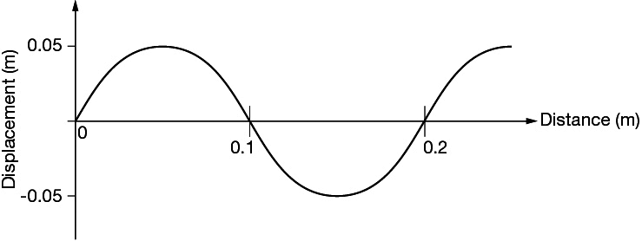

**b** The graph above should include a dot at the 0.2 m mark on the curve where it crosses   
the *x*-axis. There should also be an arrow pointing downwards. As the wave moves through the 0.2 m point a particle will be displaced downwards. (1 mark)

Question 8

 (1 mark)

Substituting *I*0 = 1370 W m–2, *d*0 = 150 m and *d*f = 108 m gives *I*f = 2640 W m–2. (1 mark)

Question 9

Destructive interference occurs when superimposed waves have opposite amplitudes and   
as a consequence partial or complete cancellation occurs. An example is when the crest of   
one water wave meets the trough of another water wave. (2 marks)

Question 10

**a** 0.4 s(1 mark)

**b**  (1 mark)

Question 11

The main concept counting towards each mark is in italics below.

Answer includes identification that *energy is transferred* from you across the valley  
and back. (1 mark)

Answer includes identification that the longitudinal wave in air is *reflected* off the opposite side of the valley. (1 mark)

Question 12

Two appropriate differences should be indicated.

The wave travels at a slower speed in the second medium compared to the first. (1 mark)

The waves will bend towards the normal as they cross the boundary. (1 mark)

Question 13

Conditions for a standing wave in a string fixed at both ends:

Two travelling waves of same frequency/wavelength and amplitude. (1 mark)

Travelling in the opposite direction. (1 mark)

Interference causes positions of maximum vibration (antinodes)   
and minimum vibration (nodes) (1 mark)

These conditions are met when the length of the string is a multiple of  (1 mark)

Question 14

a and b



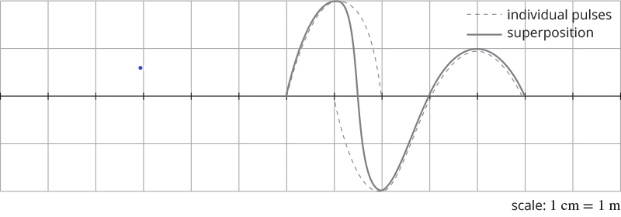

The correct amplitude and position of the two pulses is shown after 2 s   
(the waves should move 4 m in 2 s). (2 marks)

The correct shape and amplitude of superposition is shown. (1 mark)

Question 15

aThe first harmonic has nodes at either end of the string where it is fixed (at the finger and the fixed end) and an antinode in the middle of the 0.6 m of string. (1 mark)

b

(1 mark)

c  (2 marks)

Question 16

a In the diagram below, the dotted line is the original wave in the question and the solid line  
 is a quarter of a cycle later. (2 marks)

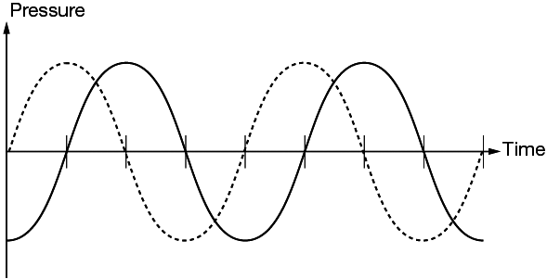

b The wave form arrives at hearing aid B a quarter of a cycle (and therefore one-quarter wavelength) after it reaches hearing aid A. The distance between A and B is 25 cm. Therefore  (1 mark)  
Hence λ = 4 × 0.25 m = 1.0 m (1 mark)

c *v* = *f*λ

 (2 marks)

**Question** 17

a Pipe 1: Assume the first frequency is the fundamental frequency.



 

And since *n* = 1, 3, 5, 7…, then this pipe is closed at one end. (2 marks)

There is an antinode in pressure at the closed end and a node at the open end. (1 mark)

The fundamental wavelength is  (1 mark)

**b** Pipe 2: Assume the first frequency is the fundamental frequency.



 

And since *n*=1, 2, 3, 4…, then this pipe is open at both ends. (2 marks)

There is a node at both of the open ends. (1 mark)

The fundamental wavelength is  (1 mark)

c For a pipe closed at one end where *n* = 3,

 (2 marks)

Alternatively, using , then the third harmonic corresponds to 2*n* – 1 = 3.



d A maximum in pressure occurs every half wavelength.

Therefore *λ* = 2 × 0.07 = 0.14 m (1 mark)

 (1 mark)

Question 18

Find the shortest wavelength the dolphin can emit, hence the largest frequency.

*f* = 130 kHz



= 1.2 cm (1 mark)

If the object is smaller than this, then diffraction (spreading of the waves) will occur around the object. (1 mark)